Walpole Swim Team
Swim Suit Order Form
Team suit and cap mandatory to participate in meets

Racing suit Includes Swim Team logo
Boys $45.00

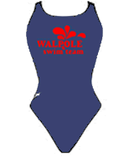
Girls $55.00

Bathing Caps Mandatory for practice

Team cap with logo:
Latex $8.00
Silicon $18.00
Purchase at sign in desk or snack bar at home meets

_______________________________________________________________________________

Fins and goggles may be purchased on-line, see website for more details

Name

Telephone Number

